# Export Audit Report Data in Liferay Portal

## Problem

Liferay comes with rich inbuilt Auditing functionality. But there is no way to get the Auditing report data out of Liferay for analysis. Data can be only viewed inside of the Liferya portal.

## Solution

A Export Audit report plugin will provide solution to download full Audit Report of portal into excel format. User can download the audit logs for specific date range using this plugin. This component will come into use only if the Audit plugin of Liferay is deployed.

How to Configure:

Step 1: Paste the war file in deploy folder on Tomcat Server

Step 2: Portlet was automatically available in control panel Configuration section

Step 3: You will be able to download audit report, provide facility to download on date basic.

**Note:** This was applicable only if Audit Report portet was already configured in portal.

Fig:1 Shows Audit Report Portlet.(no option to report generation)

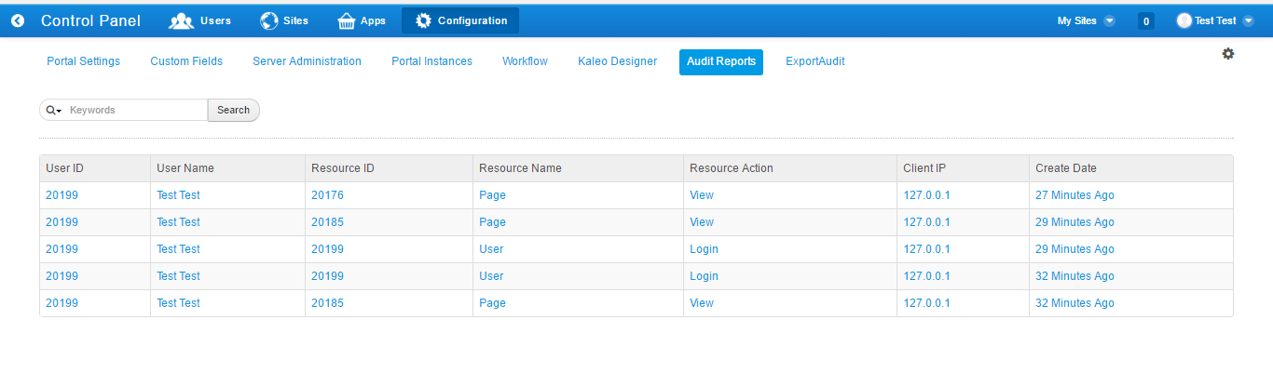

Fig 2: Export Audit Portlet displayed in Configuration section

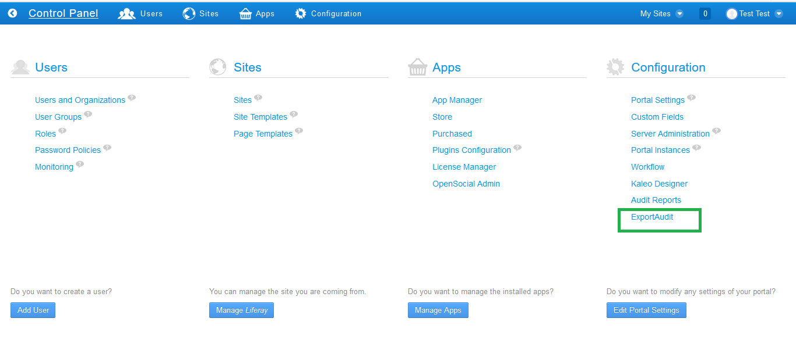

Fig 3: ExportAudit report Data

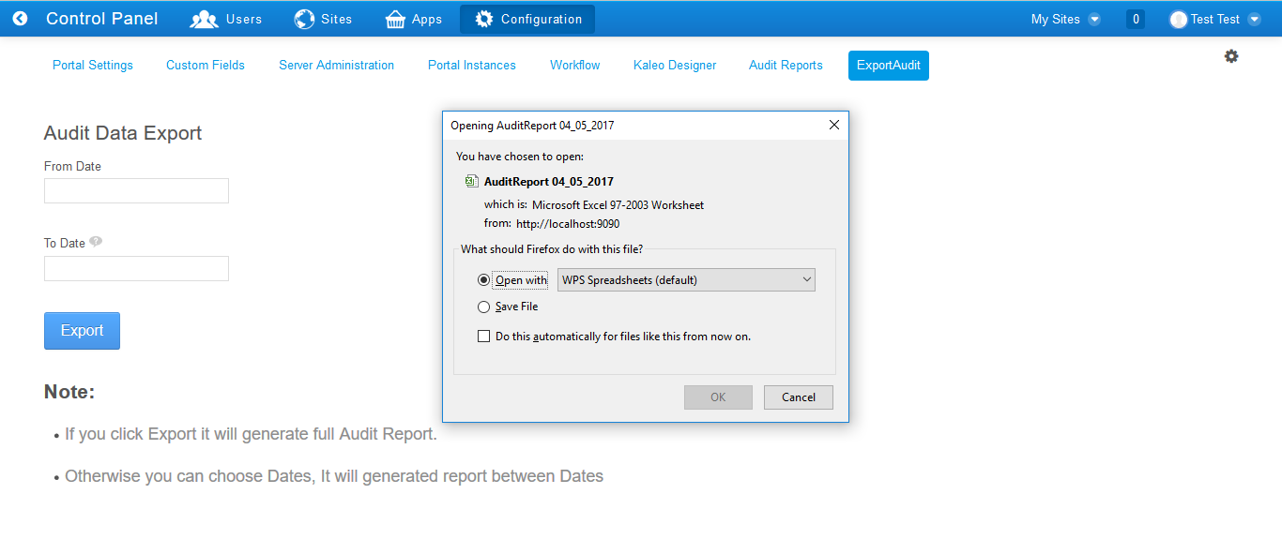

Fig 4 : Audit Report

